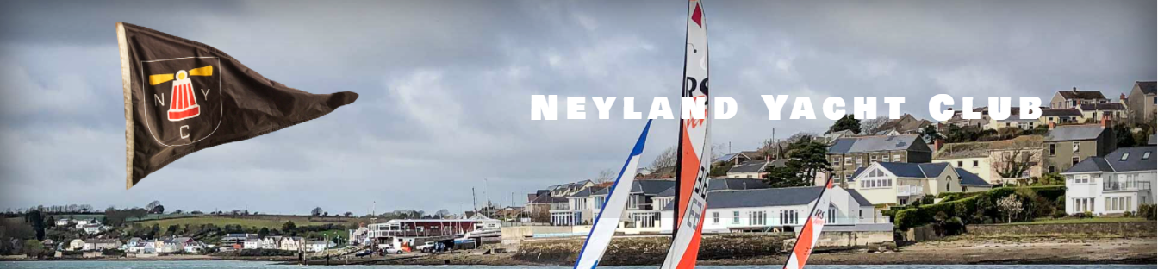

Sailing Instructions
Neyland Yacht Club Cruiser Summer Regatta
26th to 27th August 2023

1. Rules
Racing will be governed by the World Sailing Racing Rules of Sailing (RRS) 2021-2024, the prescriptions of the RYA, and class rules where appropriate except where changed by these sailing instructions.
2. Changes to Sailing Instructions
2.1 Any change to the sailing instructions will be posted before 0900 on the day it will take effect, except that any change to the schedule of races will be posted by 2000 on the day before it will take effect.
2.2 Changes to the sailing instructions may be made on the water by VHF channel 37.
3. Communication with competitors
3.1 Notices to competitors will be posted on the official notice board located at Neyland Yacht Club.
3.2 The race office is located at Neyland Yacht Club Starter’s Cabin.
3.3 On the water, the race committee intends to monitor and communicate with competitors on VHF channel 37.
3.4 The following communications may be made by the race committee on VHF channel 37:
Time checks, schedule changes, starting order of classes, courses, change of courses, shortening, postponement, abandonment, starting signals, recalls, and next start sequence.
4. Signals made ashore
4.1 Signals made ashore will be displayed at Neyland Yacht Club Starter’s Cabin.
5. Schedule of races
5.1
Saturday 26th August 2023 | Sunday 27th August 2023
Race 1  Race 2 | Race 3  Race 4

5.2 The scheduled time of the warning signal for the first race each day is 10:55.
5.3 To alert boats that a race will begin soon, the race committee may transmit a radio message on VHF channel 37.
5.4 On the last scheduled day of racing no warning signal will be made after 1700.
6. Class flags
6.1 Division 1 class flag will be numeral pennant 1. Division 2 class flag will be numeral pennant 2.
7. Racing area and course
7.1 The racing area is the Milford Haven Waterway.
7.2 The course will be transmitted on VHF channel 37 prior to the warning signal of each race.
8. Marks
8.1 Marks will be a combination of channel markers and Neyland Yacht Club racing marks (blue barrels with mark name painted on them).
9. The start
9.1 Races will be started using only sound signals at 5 minutes, 4 minutes, 1 minutes and 0 minutes before starting signal. The warning signal for each succeeding class shall be made with the starting signal of the preceding class. This changes RRS 26.
9.2 The starting line is between an orange staff at Neyland Yacht Club and a white line painted on the wall of Pembroke Dock Port. The transit line will have lights at Neyland Yacht Club to designate the line.
9.3 Boats whose warning signal has not been made shall avoid the starting area during the starting sequence for other races.
9.4 If any part of a boat’s hull is on the course side of the starting line at her starting signal and she is identified, the race committee will attempt to hail her sail number on VHF channel 37. Failure to hail her number, failure of her to hear such a hail, or the order in which boats are hailed will not be grounds for a redress for request. This changes RRS 62.1(a).
9.5 A boat that does not start within 4 minutes after her starting signal will be scored Did Not Start without a hearing. This changes RRS A5.1 and A5.2.
10. Change of the next leg of the course
10.1 To change the next leg of the course, the race committee will transmit a message on VHF channel 37.
11. The finish
11.1 The finishing line is between an orange staff at Neyland Yacht Club and a white line painted on the wall of Pembroke Dock Port. This changes RRS S11.1.
12. Time limits
12.1 The Race Time Limit (see RRS 35) and the Finishing Window are shown in the table below:
Race Time Limit | Finishing Window
2.5 hours | 45 minutes

12.2 Boats failing to finish within the Finishing Window and have not retired shall be scored Did Not Finish without a hearing. This changes RRS 35, A5.1 and A5.2.
13. Protests and requests
13.1 Hearing request forms are available at the race office. Protests and requests for redress or reopening shall be delivered there within the appropriate time limit. There is a £5 donation to the RNLI for each protest submitted.
13.2 For each class, the protest time limit is 60 minutes after the last boat has finished the last race of the day or the race committee signals no more racing today, whichever is later.
13.3 Notices will be posted no later than 30 minutes after the protest time limit to inform competitors of hearings in which they are parties or named as witnesses and where the hearings will be held.
13.4 Notices of protests by the race committee or protest committee will be posted to inform boats under RRS 61.1(b).

