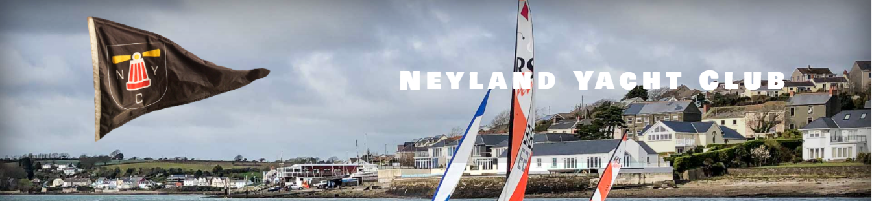

Sailing Instructions
Neyland Yacht Club Dinghy May Regatta
11th to 12th May 2024

1. Rules
Racing will be governed by the World Sailing Racing Rules of Sailing (RRS) 2021-2024, the prescriptions of the RYA, and class rules where appropriate except where changed by these sailing instructions.
2. Communication with competitors
2.1 Notices to competitors will be posted on the official notice board located at Neyland Yacht Club.
2.2 The race office is located at Neyland Yacht Club Starter’s Cabin.
3. Changes to Sailing Instructions
3.1 Any change to the sailing instructions will be posted before 1000 on the day it will take effect, except that any change to the schedule of races will be posted by 2000 on the day before it will take effect.
4. Signals made ashore
4.1 Signals made ashore will be displayed at Neyland Yacht Club Starter’s Cabin.
5. Schedule of races
5.1
Saturday 26th August 2023 | Sunday 27th August 2023
Race 1  Race 2  Race 3  Race 4  Race 5  Race 6 | Long distance race 1  Long distance race 2

5.2 The scheduled time of the warning signal for the first race each day is 1055.
5.3 To alert boats that a race will begin soon, the race committee may make a repeated sound on the horn if the race starts from the Starter’s Cabin, or by displaying an orange starting line flag with one sound signal at least five minutes before a warning signal is made if the race starts from a race committee vessel.
5.4 On the last scheduled day of racing no warning signal will be made after 1700.
6. Class flags
6.1 Division 1 class flag will be numeral pennant 1. Division 2 class flag will be numeral pennant 2.
7. Racing area and course
7.1 The racing area is the Milford Haven Waterway.
7.2 The course will be shared with competitors in the briefing at the Starter’s Cabin prior to the first race of the day.
8. Marks
8.1 Marks will be a combination of channel markers, Neyland Yacht Club racing marks (blue barrels with mark name painted on them), yellow Neyland Yacht Club drop marks, and orange large pillar Neyland Yacht Club marks.
9. The start
9.1 Races will be started using only sound signals at 5 minutes, 4 minutes, 1 minutes and 0 minutes before starting signal. The warning signal for each succeeding class shall be made one minute after the starting signal of the preceding class. This changes RRS 26.
9.2 If the start is from the Starter’s Cabin, the starting line will be confirmed at the briefing. If the start is on the water, the starting line will be between a staff displaying an orange flag on the race committee vessel and the course side of the starting mark.
9.3 Boats whose warning signal has not been made shall avoid the starting area during the starting sequence for other races.
9.5 A boat that does not start within 4 minutes after her starting signal will be scored Did Not Start without a hearing. This changes RRS A5.1 and A5.2.
10. Change of the next leg of the course
10.1 To change the next leg of the course, the race committee will transmit a message via the safety boat drivers to all competitors. Failure to inform competitors of the change, failure to hear about the change, or the order in which boats are informed will not be grounds for a request for redress.

11. The finish
11.1 If the finish is from the Starter’s Cabin, the finishing line is between an orange staff at Neyland Yacht Club and the yellow Outer Distance Mark. This changes RRS S11.1. If the finish is from a race committee vessel, the finishing line will be between a staff displaying a blue flag on the race committee vessel and the course side of the finishing mark.
12. Time limits
12.1 The Race Time Limit (see RRS 35) and the Finishing Window are shown in the table below:
Race Time Limit | Finishing Window
Saturday: 45 minutes  Sunday: 2 hours | Saturday: 15 minutes  Sunday: 45 minutes

12.2 Boats failing to finish within the Finishing Window and have not retired shall be scored Did Not Finish without a hearing. This changes RRS 35, A5.1 and A5.2.
13. Protests and requests
13.1 Hearing request forms are available at the race office. Protests and requests for redress or reopening shall be delivered there within the appropriate time limit. There is a £5 donation to the RNLI for each protest submitted.
13.2 For each class, the protest time limit is 60 minutes after the last boat has finished the last race of the day or the race committee signals no more racing today, whichever is later.
13.3 Notices will be posted no later than 30 minutes after the protest time limit to inform competitors of hearings in which they are parties or named as witnesses and where the hearings will be held.
13.4 Notices of protests by the race committee or protest committee will be posted to inform boats under RRS 61.1(b).

